|  |  |
| --- | --- |
| Name | Umar Hayyat |
| Roll No | 2019-EE-360 |

**Lab NO 4**

**If else Statement**

**Objectives:**

In this lab,

* I will learn about if and if-else statement.
* I will learn how to take input from user.

**Task 1:**

Prompt the user to enter three integers.

State whether these three integers can be the sides of a right angled triangle.

**Code:**

import java.util.Scanner;

public class Newclass {

public static void main (String [] args) {

int a, b,c;

Scanner scan=new Scanner (System. in);

System.out.println("Enter first integer");

a=scan.nextInt();

System.out.println ("Enter second integer");

b=scan.nextInt();

System.out.println ("Enter third integer");

c=scan.nextInt ();

if(a*a + b*b==c*c | b*b + c*c==a*a | a*a + c*c==b*b)

System.out.println ("sides of a right angled triangle");

else

System.out.println (" they are not sides of a right angled triangle");

System.out.println (a);

System.out.println (b);

System.out.println(c);

}}

**Output**:

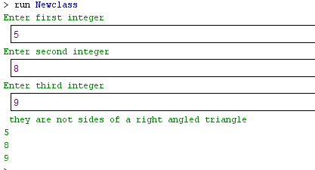

**Task 2:**

Write a program that asks a user to enter his/her age and prints whether the user is a kid, teenager or an adult using if-else statement.

Age 0-12 = Kid

Age 13-18 = Teenage

Age >18 = Adult

**Code:**

import java.util.Scanner;

public class Newclaass1 {

public static void main (String [] args)

{

int age;

Scanner name=new Scanner (System. in);

System.out.println ("Enter your age");

age=name.nextInt ();

System.out.println (age);

if (age>0 & age<=12)

System.out.println ("You are Kid");

else

if (age>=13 & age<=18)

System.out.println ("You are Teenage");

else

System.out.println ("you are adult");

}}

**Output:**

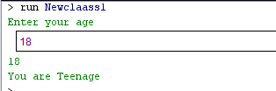

**Task 3:**

Develop a basic calculator using if-else statement which is capable of performing addition, subtraction, multiplication and division.

Hint 1: Ask the user to enter two numbers and the type of arithmetic operation to be performed.

Hint 2: Use char data type for the variable handling the operation type.

**Code:**

import java.util.Scanner;

public class Calculator

{

public static void main (String [] args)

{

int x,y;

char z;

Scanner calculate=new Scanner (System. in);

System.out.println ("Enter 1st integer");

x=calculate.nextInt ();

System.out.println ("Enter 2nd integer");

y=calculate.nextInt ();

System.out.println ("Enter which operation you want to perform");

z=calculate. next ().charAt (0);

if (z=='+')

System.out.println(x +y);

if (z=='-')

System.out.println(x-y);

if (z=='*')

System.out.println(x*y);

if (z=='/')

System.out.println(x/y);

}}

**Output:**

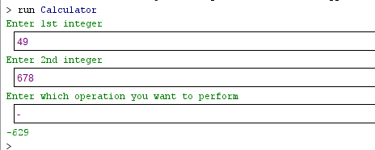

**Task 4:**

Take 5 integers from the user.

Find out the maximum and the minimum number of the five and print them on the screen.

**Code:**

import java.util.Scanner;

public class Max

{

public static void main (String [] args)

{

int a,b,c,d,e;

Scanner scan=new Scanner(System.in);

System.out.println("Enter 1st integer");

a=scan.nextInt();

System.out.println("Enter 2nd integer");

b=scan.nextInt();

System.out.println("Enter 3rd integer");

c=scan.nextInt();

System.out.println("Enter 4th integer");

d=scan.nextInt();

System.out.println("Enter 5th integer");

e=scan.nextInt();

if(a>b & a>c & a>d & a>e)

System.out.println("maximum number: "+a);

else{

if(b>a & b>c & b>d & b>e)

System.out.println("maximum number: "+b);

else

if(c>a & c>b & c>d & c>e)

System.out.println("maximum number: "+c);

else

if(d>a & d>b & d>c & d>e)

System.out.println("maximum number: "+d);

else

System.out.println("maximum number: "+e);}

if(a<b & a<c & a<d & a<e)

System.out.println("miniimum number: "+a);

else

if(b<a & b<c & b<d & b<e)

System.out.println("minimum number: "+b);

else

if(c<a & c<b & c<d & c<e)

System.out.println("minimum number: "+c);

else

if(d<a & d<b & d<c & d<e)

System.out.println("minimum number: "+d);

else

System.out.println("minimum number: "+e);

}}

**Output:**

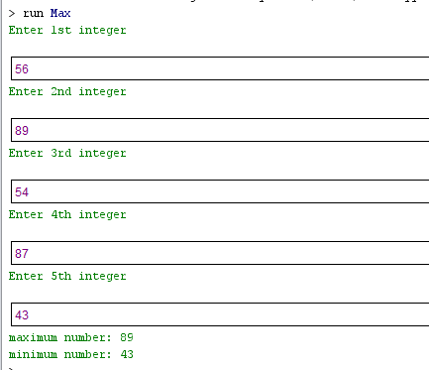

**Task 5:**

Write a C program to accept a coordinate point in a XY coordinate system and determine in which quadrant the coordinate point lies.

**Code:**

import java.util.Scanner;

public class Coordinate

{

public static void main (String []args)

{

int a,b;

Scanner point=new Scanner(System.in);

System.out.println("Enter the value of a :");

a=point.nextInt();

System.out.println("Enter the value of b :");

b=point.nextInt();

if(a>0 & b>0)

System.out.println("Points lies in 1st quadrant");

if(a<0 & b>0)

System.out.println("Points lies in 2nd quadrant");

if(a<0 & b<0)

System.out.println("Points lies in 3rd quadrant");

if(a>0 & b<0)

System.out.println("Points lies in 4th quadrant");

} }

**Output:**

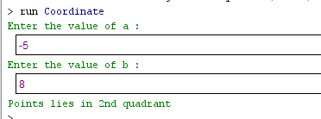

**Conclusion**:

In this lab, I learnt how we compare two or more numbers. I also learnt how we take input from user as I used Scanner class for this. I also learnt how we find maximum or minimum number by using if else statement. I also learnt that how we perform different arithematics operation by take input and operation which he want from user.